Swiss build world's longest tunnel
By Jamey Keaten Associated Press
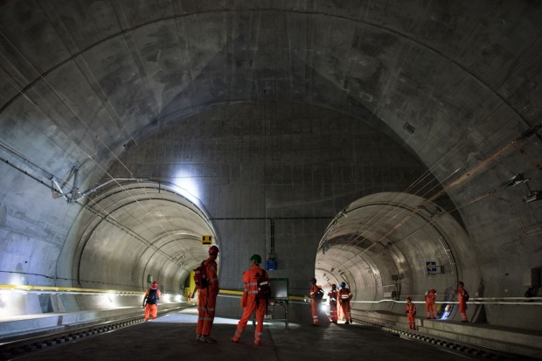

BLSD PERFORMANCE-BASED READING ASSESSMENT
Grade 10 Fall

Swiss build world's longest tunnel
By Jamey Keaten Associated Press
June 13, 2016
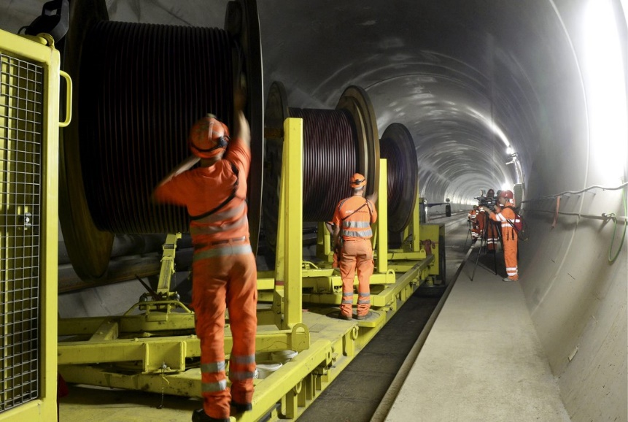
In this Oct. 31, 2013 file photo construction workers are busy in the NEAT Gotthard Base Tunnel between Biasca and Amsteg, Switzerland. (Karl Mathis/Keystone via AP, file/Urs Flueeler/Keystone via AP, file)

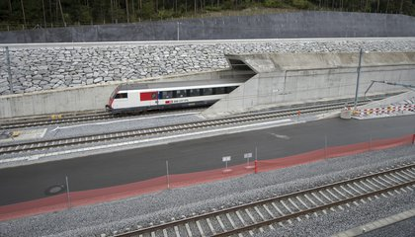
Just like Hannibal, Swiss engineers have conquered the Alps.
More than 2,200 years after the commander from the ancient North African civilization of Carthage led his army of elephants and troops over Europe's highest mountain chain, Swiss leaders have completed another gargantuan task. And they did it on time. They burrowed through the world's longest railway tunnel under the Swiss Alps to ease trade and congestion in European trade and travel.
On June 1, Switzerland inaugurated the 35.4-mile Gotthard Railway Tunnel. It is a major engineering achievement deep under snow-capped peaks. The construction was carried out over 17 years at a cost of $12 billion.
Many tunnels crisscross the Swiss Alps, and Gotthard Pass already has two. The first, also for trains, was built in 1882. But the Gotthard Base Tunnel is a record-setter. It eclipses Japan's 53.8-kilometer Seikan Tunnel as the world's longest. It bores deeper than any other tunnel, running about 1.4 miles underground at its maximum depth.
The thoroughfare aims to cut travel times, ease roadway traffic and draw cargo from pollution-spewing trucks that travel between Europe's north and south. The tunnel will open for commercial service in December. The two-way tunnel will take up to 260 freight trains and 65 passenger trains per day.
Swiss planners have dreamt of such a tunnel for decades. And it should have an impact far beyond Switzerland for decades to come.
Switzerland pulled out all the stops for the inauguration. German Chancellor Angela Merkel, French President Francois Hollande and Italian Prime Minister Matteo Renzi came for a flashy celebration featuring musical bands, dancers and even a tunnel theme song.
The EU turnout is little surprise. The project, while cutting a north-south axis through central Switzerland, has received financial support and industrial know-how from around the European Union. Though Switzerland isn't one of the bloc's 28 members, the EU railway network will get a major boost from the shortcut through the Alps, notably on the route from Germany to Italy.
"The new tunnel fits into the European railway freight corridor, which links Rotterdam and Genoa," said Swiss President Johann Schneider-Ammann.
He added that the tunnel will boost access "to these two important ports" in the Netherlands and Italy.
"Aside from saving time, more merchandise can be carried through the Alps," he said.
In a glitzy show under purple neon lights, performers dressed up in orange miners' suits and protective helmets. They danced atop a moving rail car, while others in costumes feigned wrestling. Trapeze artists hung from chains or ropes. A band blared out a thumping military march and helicopters buzzed overhead.
The tunnel runs between the German-speaking Swiss town of Erstfeld in the north and Italian-speaking Bodio in the south. Split-screen TV images showed two trains in opposite directions entering and leaving the tunnel entrances nearly simultaneously.
A test run by the European leaders turned into a sort of mini-summit. Merkel, Renzi and Hollande climbed aboard in a first-class car for a ride through the tunnel. They sat alongside Schneider-Ammann.
A band repeatedly played Rossini's "William Tell Overture" after they arrived.
Merkel said it was a "wonderful feeling" to be on the train. She did note that "more than 2,000 meters of rocks" were above but that she had a "feeling of security because I believe in the security of the Swiss civil engineers."
"We congratulate Switzerland because they were already so punctual, and also because the costs were kept within targets," she added. "That's something Germany still needs to strive for."
At the peak of construction, as many as 2,400 workers took part in the project. The two holes were connected in October 2010. It occurred some 11 years after the first blast to build the tunnel. That took place in the last century.
In the tunnel, freight trains will run up to 60 miles per hour. Passenger trains will run twice that fast at first. Long-term ambitions are for up to 250 kilometers an hour. The tunnel is to shave 45 minutes off the trip from Zurich to Lugano, Switzerland.
Guy Parmelin, the Swiss minister of defense and civil protection, told national television that the tunnel gives his country a chance to display its "know-how" and show "when Switzerland takes on a commitment, it keeps it."
Source: Smithsonian Tween Tribute http://tweentribune.com/article/tween78/swiss-build-worlds-longest-tunnel/

